MINISTRY OF YOUTH AND SPORTS
LEAGUE AMATEURS OF UKRAINE
SOCIETY FOR PROMOTION OF THE DEFENSE OF UKRAINE

UKRAINE CHAMPIONSHIP IN RADIO DIRECTION FINDING AMONG ADULTS, JUNIORS AND YOUTHS.

Bulletin

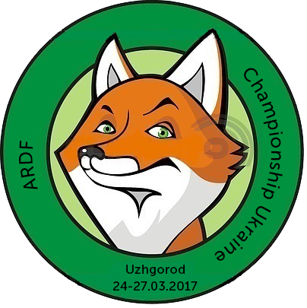
PLACE AND DATE 24-27 MARCH. C.UZHGOROD
25.03 – SPRINT
26.03 – CLASSIC 3.5 MHZ;
26.03 – CLASSIC 144 MHZ., ;
27.03 - FOXORING

ORGANIZATOR: LEAGUE AMATEURS OF UKRAINE
ZAKARPATSKYI RCSTWSY
DEPUTY CHIEF JUDGE OF ORGANIZATIONAL ISSUES
IVANCHYKHIN MYKOLA +38 050 641 2842
nicko.55@bk.ru

CREDENTIALS COMMITTEE AND THE JURY WILL WORK TO:
UZHGOROD, STREET ZANKOVETSKA 5/22, A SPORTS COMPLEX "YOUTH".
TO GO FROM THE TRAIN STATION BY SHUTTLE NUMBER 3,8, 10, 12k, 14, 21, 156 TO STOP
"DEPARTMENT STORE UKRAINE "(UNIVERMAG UKRAINA)

CHAMPIONSHIPS PROGRAM
24.03.2017:
by 13.00 – CHECK IN;
15.00–18.00 – SPRINT
19.00–20.00 – JUDGES SEMINAR
25.03.2017:
10.00–17.00 – CLASSIC 3.5 MHZ;
26.03.2017:
10.00–17.00 – CLASSIC 144 MHZ., .
27.03.2017:
10.00–15.00 – FOXORING;
16.00–17.00 – AWARDING;

MAPS:
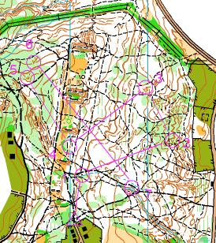
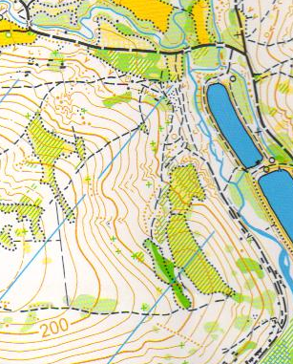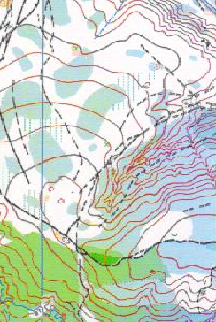
SPRINT CLASSIC FOXORING
Scale maps for classic and foxoring are 1:15000, sprint 1:5000, H=5.Wood is conifers and deciduous, good and average permeability. Dengerous places are steeps slopes.

AGE CATEGORIES OF COMPETITORS:
W14, M14, W16, M16, W19, M19, W21, M21, W35, M40, W50, M50, W60, M60, and M70

APPLICATION:

All of participants must apply on time with all necessary documents. Deadline is 19.03.2017 18.00. Application form available on the site:http://ardf.org.ua/

FEES

Starting fees (including transportation to the start and from the finish, maps,chip)
4 EUR per competition
We will use E-mark SportIdeant

EXPRESSION OF RESULTS AND AWARDS

Winners in the individual and team competition are determined in each age group and awarded medals and diplomas.

ADDITIONAL INFORMATION

If you want to book accommodation, please advance organizers warm. There are a lot of available cares, canteens and restaurants.

WELCOME TO UKRAINE

